<Image Gallery Software>

Use-Case-Realization Specification: <Logout>

Version <1.0>

Revision History

|  |  |  |  |
| --- | --- | --- | --- |
| **Date** | **Version** | **Description** | **Author** |
| <dd/mmm/yy> | <1.0> | <details> | Nguyen Kiem Hoa |
|  |  |  |  |
|  |  |  |  |
|  |  |  |  |

Table of Contents

1. Introduction 4

1.1 Purpose 4

1.2 Scope 4

1.3 Definitions, Acronyms, and Abbreviations 4

1.4 References 4

1.5 Overview 4

2. Use-Case Specification 4

3. Interaction Diagrams 5

4. Class Diagrams 6

5. Derived Requirements 7

Use-Case-Realization Specification: <Log out>

# Introduction

## Purpose

This document describes how the Logout Use-Case is realized within the design model, in terms of collaborating objects.

## Scope

This document applies to the Image Gallery Software which will be developed Group 5C-18.

## Definitions, Acronyms, and Abbreviations

User – a person who use the software.

## References

None.

## Overview

In the following section, Use-Case Realization Specification of the Logout Use-Case of the Image Gallery Software is provided in detail. The first section is a textual description of the Use-Case specification. The following section contains diagrams (sequence and collaboration diagrams) describing how the use case is realized in terms of collaborating objects. The third section includes class diagrams with relationships that participate in the realization of the use case. The last section is an analysis of all requirements, such as non-functional requirements, on the use-case realization that are not considered in the design model, but that need to be taken care of during implementation.

# Use-Case Specification

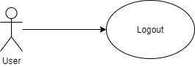

|  |  |
| --- | --- |
| **Name** | Logout |
| **Brief Description** | A user loging out the system |
| **Actor** | User |
| **Flow of Events** | |
| **Basic Flow** | |
| 1. User chooses to signout. 2. The system logging out the user. | |
| **Alterante Flows** | |
| None. | |
| **Pre-Conditions** | |
| User is logged in the system. | |
| **Post-Conditions** | |
| The user exit from software. | |
| **Extension Points** | |
| None | |

# Interaction Diagrams

**Sequence Diagram:**

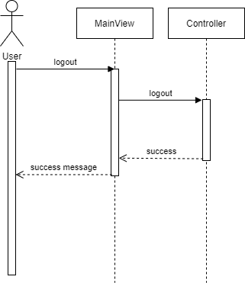

**Collaboration Diagram:**

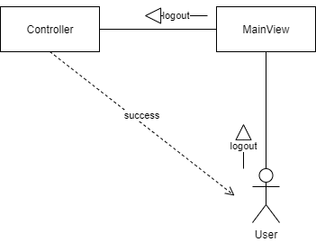

# Class Diagrams

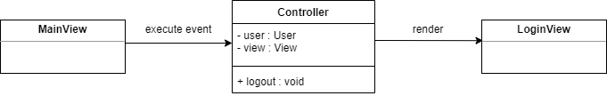

# Derived Requirements

None.